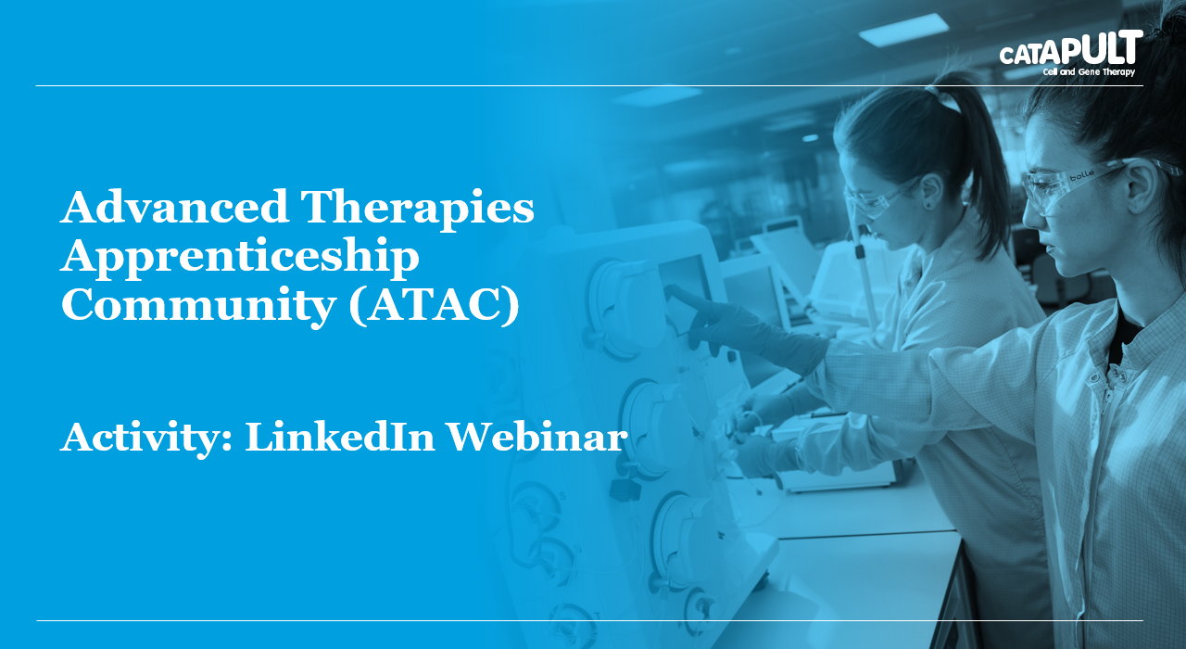

LinkedIn is widely considered the benchmark for professional networking social media platforms. Used correctly it can be an invaluable tool for your career development, increasing understanding of your professional environment and keep you up to date with the latest advances. Even if you choose not to spend a lot of time on LinkedIn it's still worth taking 30 minutes to set up your complete LinkedIn profile and understand the basics. The aim of this webinar is to give you the basic elements of what the platform is used for, how to build your profile and important considerations for maintaining your professional brand.

Target Audience: Apprentices new to the industry or those wanting to learn more about LinkedIn as a professional social networking platform
Duration: 1 hr Webinar
Learning Outcomes:
- How to build a professional LinkedIn profile
- Aspects and features of LinkedIn vs other social media platforms
- How to use the LinkedIn to further your career in Advanced Therapies

